BookyourbooK

A Mini-Project Report
Under
Implementation of Technology
Year 2014-2015

NAME OF THE CANDIDATE
Submitted by
Harsh Mody
Dhawal Mehta



Under The Guidance Of
Prof. Ratnesh Chaturvedi

in partial fulfillment for the award of the degree
of
Bachelor of Technology
IN
Computer Engineering
at
Mukesh patel school of technology management and engineering, nmims

Month and year
21st April, 2015

CERTIFICATE

This is to certify that the project entitled “bookyourbook” is the bonafide work carried out by Harsh Mody and Dhawal Mehta of B.Tech (Computer Engineering), MPSTME (NMIMS), Mumbai, during the IV semester of the academic year 2014-2015, in partial fulfillment of the requirements for the award of the Degree of Bachelors of Technology as per the norms prescribed by NMIMS. The mini-project work has been assessed and found to be satisfactory.

___________________
Prof. Ratnesh Chaturvedi

_______________________ ________________________
Examiner 1 Examiner 2

________________________
Dean
Dr. Sharad Mhaiskar

DECLARATION

We, Dhawal Mehta and Harsh Mody Roll No. E008 , E013 respectively, of B.Tech (Computer Engineering), IV semester understand that plagiarism is defined as anyone or combination of the following:
- Un-credited verbatim copying of individual sentences, paragraphs or illustration (such as graphs, diagrams, etc.) from any source, published or unpublished, including the internet.
- Un-credited improper paraphrasing of pages paragraphs (changing a few words phrases, or rearranging the original sentence order)
- Credited verbatim copying of a major portion of a paper (or thesis chapter) without clear delineation of who did wrote what. (Source: IEEE, The institute, Dec. 2004)
- I have made sure that all the ideas, expressions, graphs, diagrams, etc., that are not a result of my work, are properly credited. Long phrases or sentences that had to be used verbatim from published literature have been clearly identified using quotation marks.
- I affirm that no portion of my work can be considered as plagiarism and I take full responsibility if such a complaint occurs. I understand fully well that the guide of the seminar/ project report may not be in a position to check for the possibility of such incidences of plagiarism in this body of work.

Signature of the Students:

Name: Dhawal Mehta and Harsh Mody.
Roll No. E008 , E013

Place:
Date:

Acknowledgement

This project consumed huge amount of work, research and dedication. Still, implementation would not have been possible if we did not have a support of many individuals and organizations. Therefore we would like to extend our sincere gratitude to all of them.

We are also grateful to Ratnesh Chaturvedhi - Proff. NMIMS MPSTME Mumbai for provision of expertise, and technical support in the implementation. Without their superior knowledge and experience, the Project would like in quality of outcomes, and thus their support has been essential.

Also for providing necessary guidance concerning projects implementation.

We would like to express our sincere thanks towards volunteer researchers who devoted their time and knowledge in the implementation of this project.

Nevertheless, we express our gratitude toward our families and colleagues for their kind co-operation and encouragement which help us in completion of this project.

Table of contents

CHAPTER NO. TITLE PAGE NO.
List of Figures i
List of Tables ii
Abbreviations iii
Abstract iv
1. INTRODUCTION
1.1 Project Overview
1.2 Hardware Specification
1.3 Software Specification

2. REVIEW OF LITERATURE
2.1 …
3. ANALYSIS & DESIGN
4. METHODS IMPLEMENTED
5. RESULTS & DISCUSSION
6. CONCLUSION & FUTURE SCOPE
REFERENCES
APPENDIX

Abstract

The purpose of the study:
Android powers hundreds of millions of mobile devices in more than 190 countries around the world. It's the largest installed base of any mobile platform and growing fast—every day another million users power up their Android devices for the first time and start looking for apps, games, and other digital content.
Android gives you a world-class platform for creating apps and games for Android users everywhere, as well as an open marketplace for distributing to them instantly.

Powerful development framework
Easily optimize a single binary for phones, tablets, and other devices.
Android gives you everything you need to build best-in-class app experiences. It gives you a single application model that lets you deploy your apps broadly to hundreds of millions of users across a wide range of devices—from phones to tablets and beyond.
Android also gives you tools for creating apps that look great and take advantage of the hardware capabilities available on each device. It automatically adapts your UI to look its best on each device, while giving you as much control as you want over your UI on different device types.
For example, you can create a single app binary that's optimized for both phone and tablet form factors. You declare your UI in lightweight sets of XML resources, one set for parts of the UI that are common to all form factors and other sets for optimzations specific to phones or tablets. At runtime, Android applies the correct resource sets based on its screen size, density, locale, and so on.
To help you develop efficiently, the Android Developer Tools offer a full Java IDE with advanced features for developing, debugging, and packaging Android apps. Using the IDE, you can develop on any available Android device or create virtual devices that emulate any hardware configuration.
1.5 billion downloads a month and growing. Get your apps in front of millions of users at Google's scale.

Open marketplace for distributing your apps
Google Play is the premier marketplace for selling and distributing Android apps. When you publish an app on Google Play, you reach the huge installed base of Android.
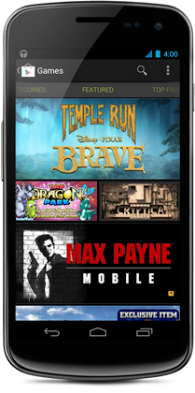
As an open marketplace, Google Play puts you in control of how you sell your products. You can publish whenever you want, as often as you want, and to the customers you want. You can distribute broadly to all markets and devices or focus on specific segments, devices, or ranges of hardware capabilities.
You can monetize in the way that works best for your business—priced or free, with in-app products or subscriptions—for highest engagement and revenues. You also have complete control of the pricing for your apps and in-app products and can set or change prices in any supported currency at any time.
Beyond growing your customer base, Google Play helps you build visibility and engagement across your apps and brand. As your apps rise in popularity, Google Play gives them higher placement in weekly "top" charts and rankings, and for the best apps promotional slots in curated collections.
Preinstalled on hundreds of millions of Android devices around the world, Google Play can be a growth engine for your business.

Why this application?
BookyourbooK is a basic platform for students to exchange books on a regular basis. The user has to log in through its assigned i’d and the application will take you to your status page or the setup page depending on your mode, of use which will give options for sell , buy or the occasional about us. The major attraction of this application is the ease of use . The database of the application has registered the prescribed books and selection of one of the books will give the user the option to buy or sell.

The methodology used:

Android Studio:
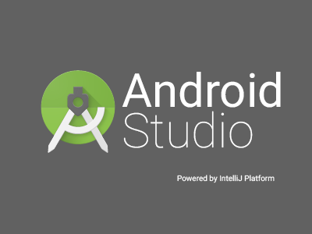

SDK MANAGER:

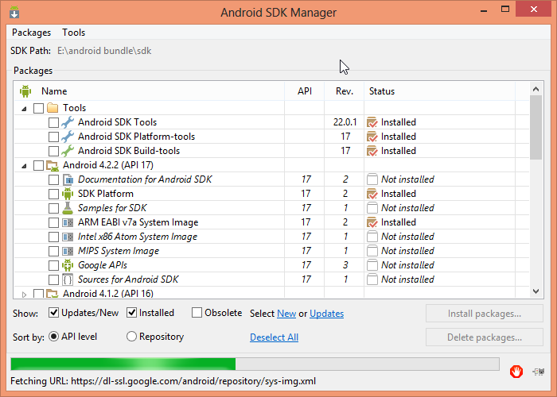

Conclusions:

We successfully implemented our idea for an android application. We have understood the basics of making an android application and have achieved by bringing something new to the market with our idea

Recommendations:

The basic or the origin of this application is souly based on the student market and hence does not include everyone using an android based device.

Abbreviations

Abbreviation | Description
ADB | Android Debugging Bridge
ADT | Android Development Tools
Android SDK | Android Software Development Kit
ART | Android Runtime
CPU | Central Processing Unit
CR | Class Representative
GPU | Graphic Processing Unit
HoD | Head of Department
IPS | In-Plane Switching
LCD | Liquid Crystal Display
RAM | Random Access Memory
SQL | Structured Query Language
SR | Student Representative
XML | Extensible Markup Language

List of Figures:

New users :
The application will ask you the follwing questions these can be considered as requirements for using this application.

Step 1: Select Course
MBA Tech
B.Tech
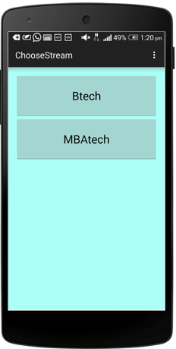

Step 2: Select Stream
Computer Science Enginering
Mechinica Engineering
Chemichal Engineering
Electronics and Telecommunication Engineering
Civil Engineering
IT Engineering

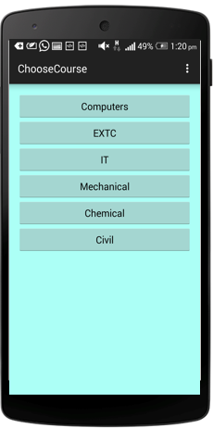

Step 3:Select Semester
Sem 1 - Sem 8

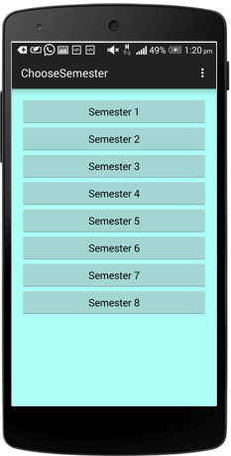

Step 4: Select Subject
Engineering Mathematics
Proffesional Ethics
Operating System
Implemenation of Technology
Computer Networks

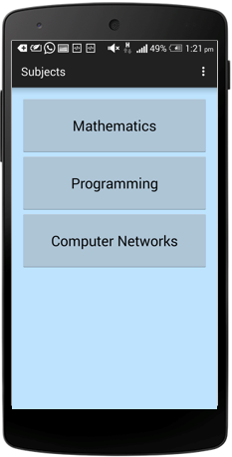

Step 5:Select Book:
G.V Kumbhojkar
H.K Das

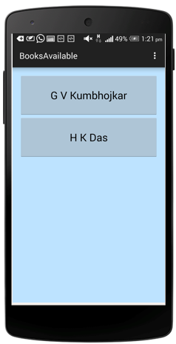

Present Users:
Application will open a status page which will have the books which have been put up by the user either buy or sell.
A notification drawer which have the options to Sell, Buy or About us.
Selling will open the page to the books which you want to sell.
Buying will open the page to books which are available to buy.
The rate of the book will be mentioned along with the current picture of the book so the consumer can have a first hand look at the purchase.

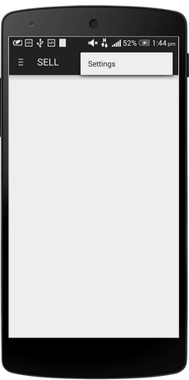

Long Press To avail options:

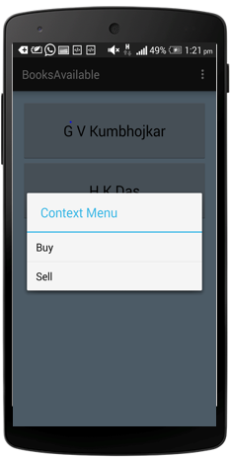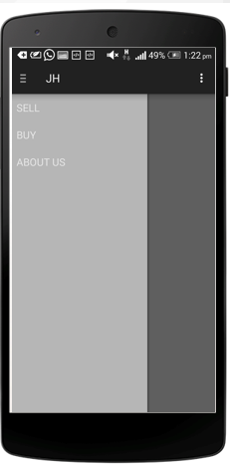

.

INTRODUCTION

Why this application?
BookyourbooK is a basic platform for students to exchange books on a regular basis. The user has to log in through its assigned i’d and the application will take you to your status page or the setup page depending on your mode, of use which will give options for sell , buy or the occasional about us. The major attraction of this application is the ease of use . The database of the application has registered the prescribed books and selection of one of the books will give the user the option to buy or sell.

Project Overview:

This app came to us from our experiences as college students.
We have made this app to make life easier for any college student.
It helps them to save and make money

Simple searching for books you need.
Easily find price quotations with books.
Buy books from fellow students at your own convenience.
Simple process for selling books without any hassle.
Keep check on status of your books

No more middleman ( so no more commission )
Simpler process for buying and selling of books.

Considering colleges that don’t have blackboard, this will serve as a means for communication
between students in a class. Other than colleges, this can be implemented for a larger community by implementing it for an organization or a company.

To Buy:

User selects subject.
User searches for the book he requires.
App displays all available options.
User can now choose from the available sellers depending on book condition , price, edition , etc.
User can now request for the book and contact seller.

To Sell:
Select subject.
Select book.
Take a picture of your book.
App displays current price and recommended price.
User can now quote his price or just select recommended price.
App gives final summary for confirmation.
Book is now awaiting buyers(Status page).
Book status can be checked on status page.
App notifies you once any buyer requests your book.
Buyer seller can now carry forward their transaction.

Hardware Specification
Classify is not a hardware intensive application, thus requires very basic level of hardware, as its application ranges across all devices, low end to high end, phones to tablets. Thus, the following are the minimum hardware specifications required to run the application:
- Processor:
  - 1 GHz ARM Cortex A8 based CPU core
  - PowerVR SGX 540 GPU.
- Memory:
  - 512 MB of RAM
  - 1 GB of Flash Memory
  - Micro-SD card slot (Optional)
- Screen:
  - 3.5-inch LCD display
  - Capacitive or Resistive touch

During Development of the application, HTC One and Sony Xperia SP were used to develop the application on mobiles was used to develop the application on a tablet. Following are the specifications:
- SONY Xperia SP:
  - Processor:
    - Quad-core 1. GHz Krait Snapdragon APQ600
    - Adreno 320 GPU
  - Memory:
    - 1GB of RAM
    - 8GB of Flash Memory
  - Screen:
    - 4.7-inch IPS LCD
- HTC One:
  - Processor:
    - 2.5 GHz Qualcomm Snapdragon 801
    - Adreno 330 GPU
  - Memory:
    - 2GB of RAM
    - 16GB of Flash Memory
  - Screen:
    - 5.5-inch IPS LCD display

- ASUS Google Nexus 7:
  - Processor:
    - 1.2 GHz NVIDIA Tegra 3 CPU
    - ULP GeForce GPU
  - Memory:
    - 1 GB of RAM
    - 16GB of Flash Memory
  - Screen:
    - 7-inch IPS LCD display

Software Specifications:

Class-ify is made on Android SDK API 22, which is primarily for android 5.0 Lollipop. This also has backward compatibility to previous APIs. Class-ify is designed to work on Android 4.0, Ice Cream Sandwich and above.
Apart from Android 4.0 and above, the application, like most android applications can run on the following Operating Systems:
- Blackberry OS 10.2
- Blackberry OS 11
- Sailfish OS
- Chrome OS
- Color OS
- IUNI OS
- YUN OS
- Nokia X mobile Platform
- Amazon Fire OS
- Tizen OS
- Android x86 (Intel Based devices)
- DuOS-M
Some of these are based on android, while some (BBos 11, Sailfish OS) are made compatible to run android applications.
Following is the list of Android versions on which Class-ify has been tested:
- Android 4.0 (Ice Cream Sandwich)
- Android 4.2 (Jellybean)
- Android 4.3 (Jellybean)
- Android 4.4 (KitKat)
- Android 5.0 (Lollipop)
- Android 5.0.2 (Lollipop)
- Android 5.1 (Lollipop)

This gives the application a broad platform, as these operating systems are in majority of smart phones being used by prospective users.

Review of Literature

The answer is simple bookyourbook started with a simple thought of helping the hostel students by implementing new methods which WORK.
Whether it be a restaurant finder
OR
A menu , order, receive payment service.
And NOW:
The online book replacement target
Being Students ourselves the constant look out for books to study from is the toughest task till the exam date appears.

Stationery vendors increase the price of the books as and when it seems right to them and having no clue the customers are over-priced.

This endless cycle has to stop and this application is the perfect tool to provide the nesecarry deadlock.

Analysis and Design

During the conception of the application, the requirements were mapped out first. This included analyzing the need of this application, its features and figuring out a list of functions it would perform during operation. This largely consisted of the analysis.
After performing a complete analysis, the design of the application was pursued. bookyourbook is designed using a hybrid design of Holo Design and Material Design elements. Material Design was introduced very recently with the launch of Android 5.0 (Lollipop), whereas Holo design was used since Android 3.0 (Honeycomb). The design also involved the organization of the GUI and the application’s databases.

Requirements:

When analyzing the requirement of the application, following points came to light for the need of bookyourbook:

- An andriod version of 3.1 API 11 or above.
- A basic internet connection
- Blackboard’s Mobile Client is not adopted as widely by the students.
- Blackboard is cluttered with information, where notifications are missed out quite frequently by a student.
- An andriod version of 3.1 API 11.
- The announcements on class groups and forums are lost among a hoard of other messages of lesser significance.
- There is no central portal for peers to ask each other for help in studies, and the potential of such sessions isn’t completely used, as many people miss out on them due to lack of notification in any form.
- The existing methods of announcement and notifications don’t reach the audience fast enough, in a noticeable manner.
- Students don’t check their emails very frequently, where the existing mechanism of updates relies on.

Advantages:

Simpler, Quicker and Easier way to apply for the purchase of a book.
After Blackboard, it will be one step towards eco-friendly management of data.
No need for students to go to book centres and unjustly waste money.
One can even have an interactive conversation with the seller which will most of the time be a senior .

Features:
Users can decide whether or not to display phone numbers
Only email ID is essential
Sellers immediately notified once which buyer requests their book
Buyers and sellers can mutually decide on a safe location for conducting the transaction
Can search for books from the safety of their homes
Address of users not displayed
Add any e-content available.
Different window for event notifications.
Get seen acknowledgements for posts.
Notify urgent submissions to the user.
Simple user interface
Easy to locate books
Efficient search of buyers and sellers
Sellers immediately notified once buyer requests book
Simple process to connect buyers and sellers

Methods Implemented
Android Studio:
MiniSQL:2
Login:
Validation:
Levels of Access:
MAB:
Notifications:2
Screenshots:2

RESULTS & DISCUSSION:

Results:
1. Black Box: In black-box testing, the AUT is validated against its requirements considering the inputs and expected outputs, regardless of how the inputs are transformed into outputs. Testers are least concerned with internal structure or code that implements the business logic of the application. There are four primary techniques to design test cases for black box testing;
2. White Box: Primary focus of this methodology is to validate, how the business logic of application is implemented by code. Internal structure of the application is tested and the techniques available to do so are;
i. Code Coverage
ii. Path Coverage
Both the above listed techniques contain several other strategies that may be discussed in some other article. Some techniques are discussed in ‘Test Case Design Techniques’ topic.
3. Grey Box: Practically speaking, this is a mixture of black box and white box. In this methodology, mainly the tester tests the application as in black box. But, for some business critical or vulnerable modules of application; testing is done as white box.

Discussion:
App can be extended to not only college textbooks
Add book recommendation service
Incorporate in app chat for users
Add book delivery service
Can also be linked to college services such as blackboard

Conclusion and Future Scope

Conclusion:

We successfully implemented our idea for an android application. We have understood the basics of making an android application and have achieved by bringing something new to the market with our idea

Future Scope:
Future of the application will be to expand this idea to all the colleges in and around mumbai and taking it to a national scale.
App can be extended to not only college textbooks
Add book recommendation service
Incorporate in app chat for users
Add book delivery service
Can also be linked to college services such as blackboard
App can be extended to not only college textbooks
Add book recommendation service
Incorporate in app chat for users
Add book delivery service
Can also be linked to college services such as blackboard

References:

Viewing numerous online videos recommended by Sir
The tools are just a tap away on the https://developer.android.com/training/index.html
http://www.tutorialspoint.com/android/

www.tutorialspoint.com
www.developer.android.com/basics/firstapp/creating-project.html
www.stackoverflow.com

